## User Manual

**Virtual Kitchen**

When the application starts, you will be positioned at the entrance of the kitchen where you can get a complete view of all its components. The Code Menu will be displayed in front of you, and will move with you as you navigate around the kitchen with the hand-controller. You will also be able to use 2 wands, the grabbing wand and the pointing wand, both of which are described below.

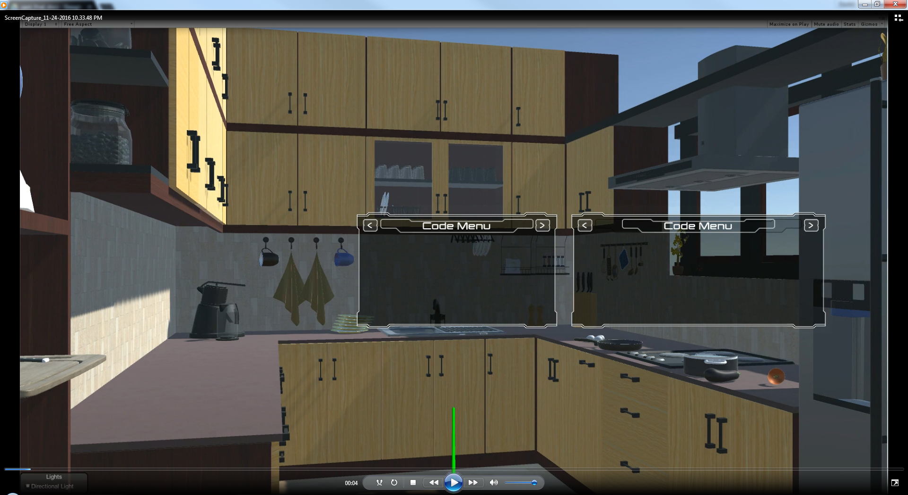

Fig. D.1 – Virtual Kitchen

**GrabbingWand**

The GrabbingWand can be used to grab and move objects in the virtual kitchen. To do so:

1. Press the Select Wand button on the controller until the blue-colored wand has been selected.
2. Point the wand towards an object, making sure that it goes through the object.
3. While the wand is going through the object, press down and hold the Activate Wand button.
4. The object will be attached to the wand as long as the Activate Wand button is held down.
5. You can move the object around by moving the wand.
6. You can walk while you are grabbing an object.
7. To release the object, release the Activate Wand button.

Notes: Only one object can be grabbed at once. The Grab function makes some objects go through walls, floor, etc.

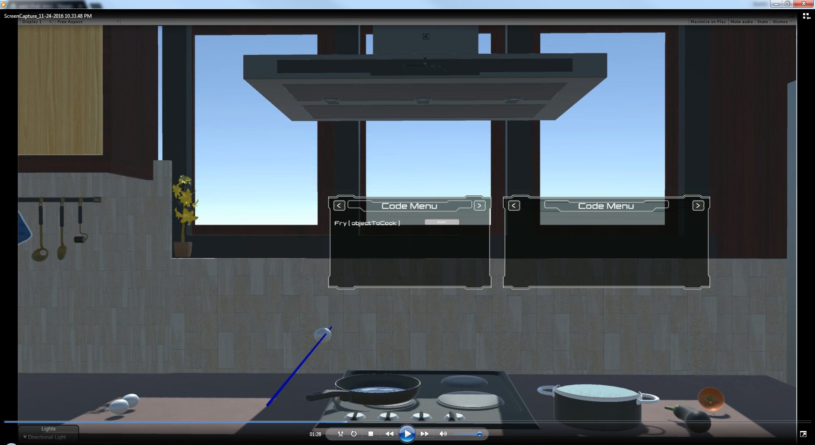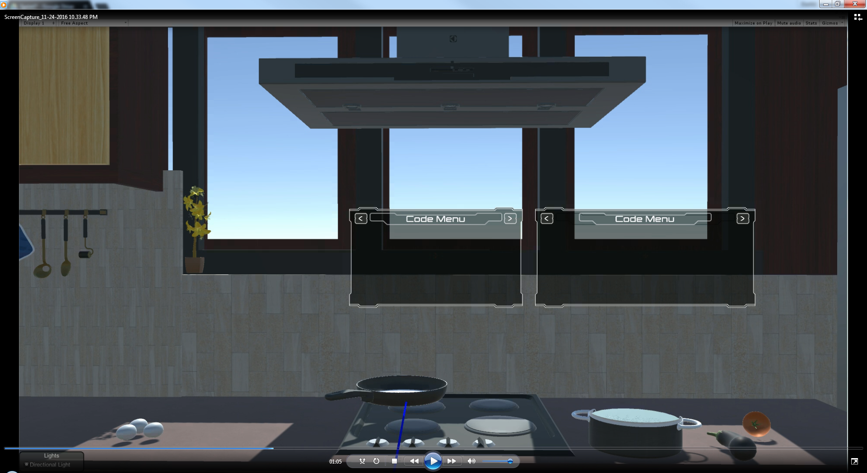

Fig. D.2 - Using the GrabbingWand to move a stoveObject and a foodItem

**PointingWand**

The PointingWand can be used to press the button of the Code Menu. To do so:

1. Press the Select Wand button until the green-colored wand has been selected.
2. Point the wand towards the button you wish to press.
3. The button will highlight indicating that the wand is on top of the button.
4. Once the button has highlighted, press on the Activate Wand button to activate the Menu Code button.
5. The PointingWand does not collide with other objects. It can be moved around and will go through any other object.

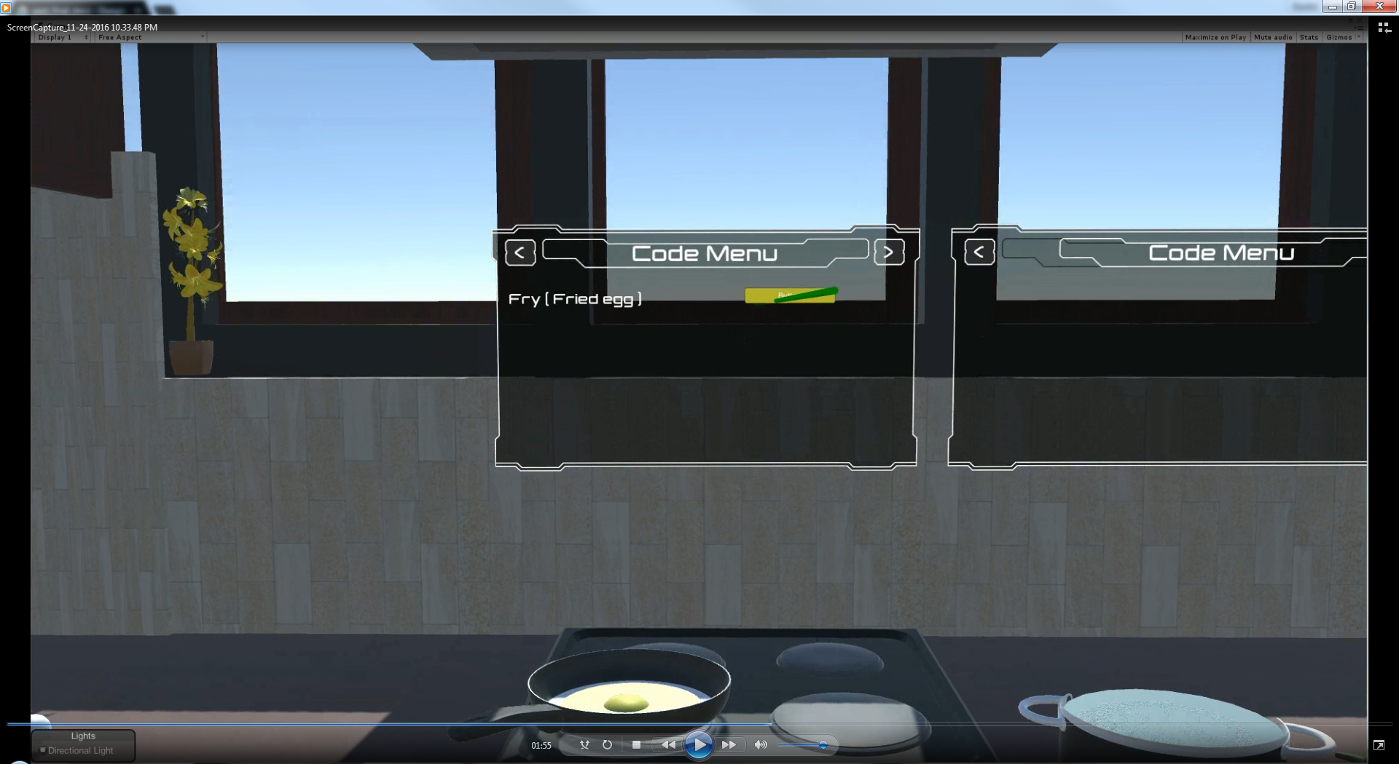

Fig. D.3 - Using the PointingWand to interact with the button in Code Menu

**Cooking a foodItem**

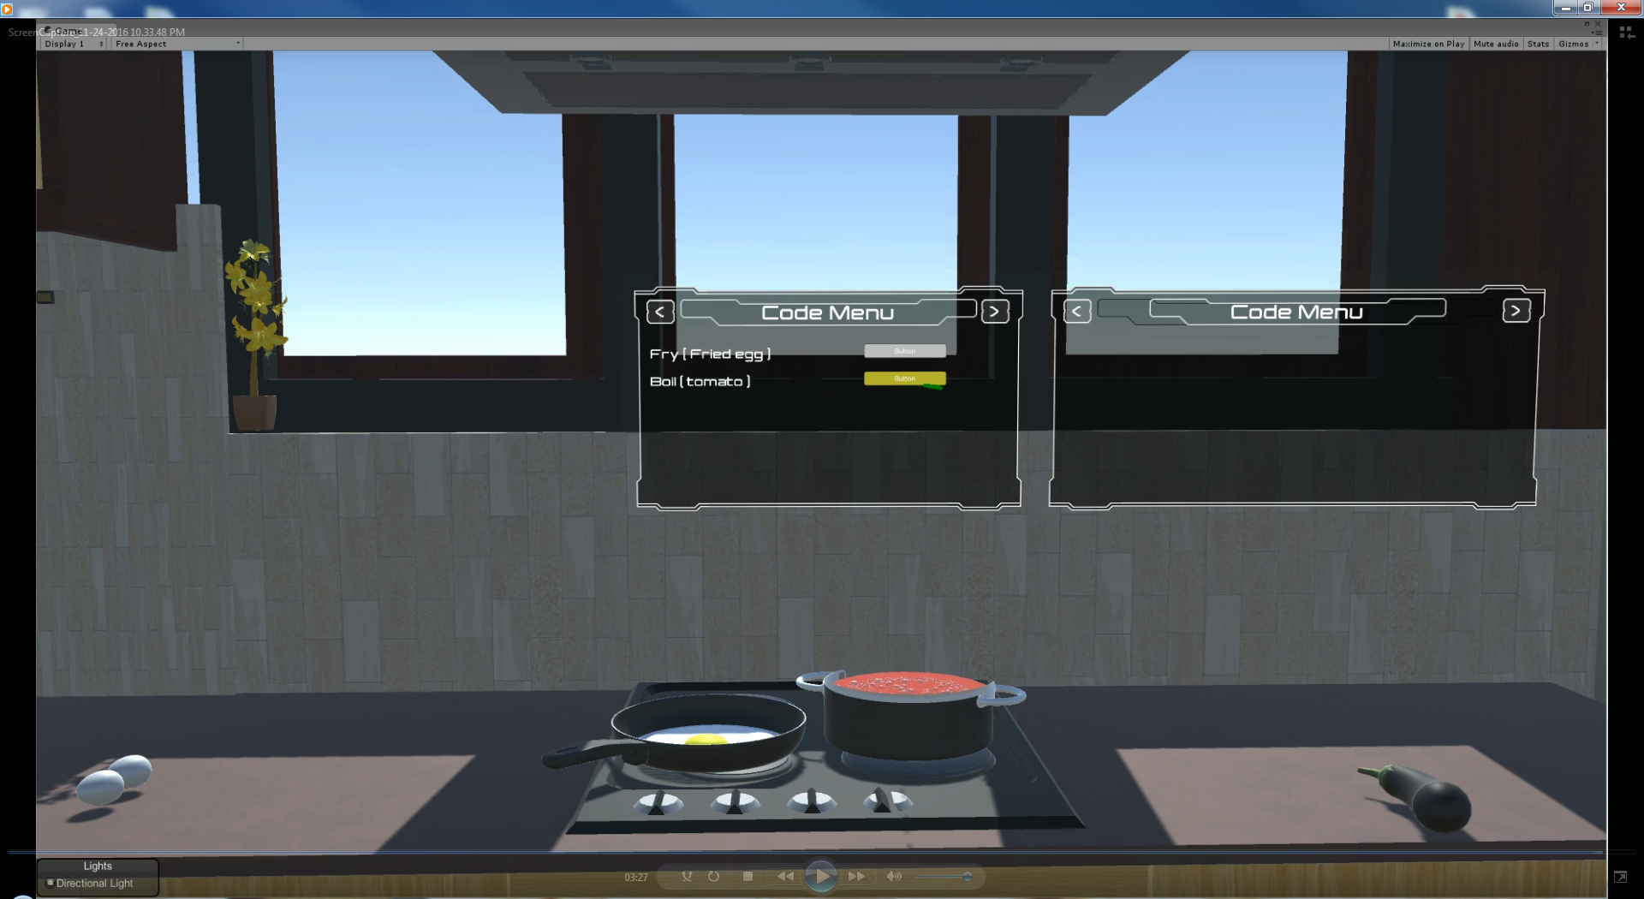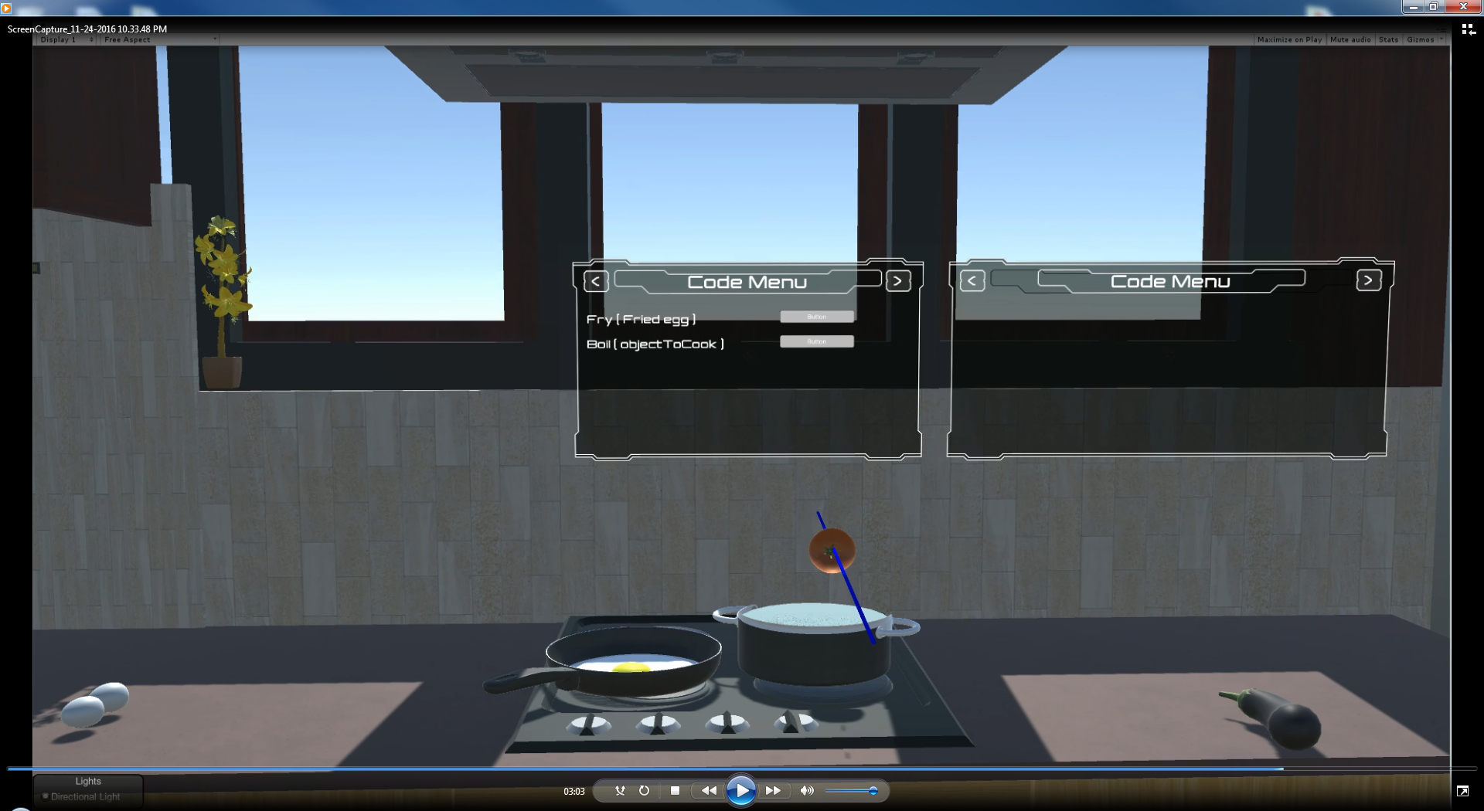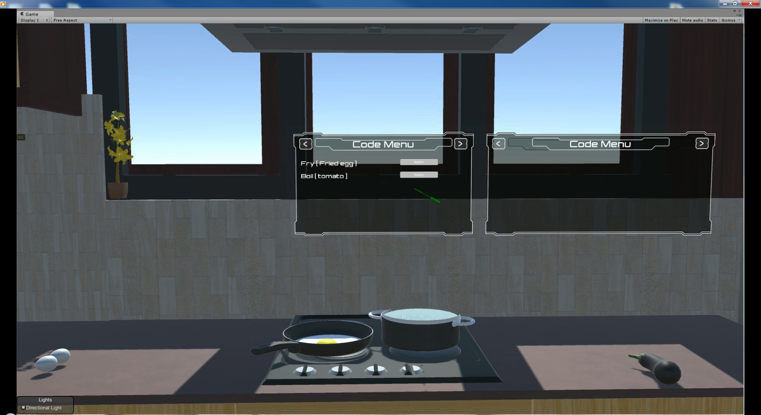

##### Fig B.5 - Creating tomato soup by placing a tomato in the cooking pot

FoodItems can be placed on stoveObjects that are on the stove. This will activate the button on the Menu Code with the foodItem’s corresponding cook function. The process to cook a foodItem is as follows:

1. Use the GrabbingWand to place a stoveObject on top of the stove.
2. Use the GrabbingWand to place a foodItem on top of the unoccupied stoveObject.
3. Locate the Menu Code and the line of code that corresponds to the foodItem-stoveObject combination.
4. Using the PointingWand, press on the button next to the line of code from the previous instruction.
5. Once the button is pressed, the cooking function will execute and a new output will display.

Notes:

1. Only one foodItem can be cooked at a time.
2. Steps 1 and 2 can be interchanged but it is not suggested (bugs).
3. The boiling pot can only be used once per execution of game.
4. The frying pan can be used multiple times during one execution of game.
5. To remove a foodItem from the frying pan, grab the frying pan and tilt it so that the foodItem slides of the pan. (The food is too hot to be grabbed directly!)

**Object Interactions** (for Stove Objects)

StoveObjects

* Frying pan
* Boiling Pot

FoodItems-Fry

* Egg
* Chicken (after chopping)
* Cheese (after chopping)
* Fries (after chopping potato)

FoodItems-Boil

* Tomato
* Eggplant

Items from stoveObjects list can be placed on top of the stove. Doing this will start a function call. Then an item from the foodItems list can be placed in its corresponding stoveObject. FoodItems from the Fry list do not execute cook function when they are in the boiling pot and vice-versa for the items in the Boil list.

**Chopping Food Items**

There are several food items that you can use for chopping. Proceed as follows:

1. Use the Grabbing Wand to grab the chopping board from the shelf and place it anywhere on the platform
2. You will see the Code Menu update with the function *Chop()*
3. Go back to the shelf and grab one of the food items that can be chopped (see Object Interactions for which items have the chopping functionality)
4. Place the food item on the chopping board
5. You will see the Code Menu update with the function *Chop(FoodItem)*

## 

##### Fig B.6 - Code menu updates when FoodItem is placed on PlatformObject

1. Using the Pointing Wand, point at the food item or the chopping board, and then activate the wand

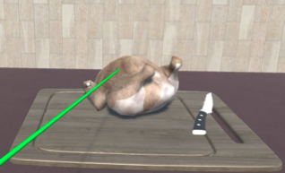

##### 

##### Fig B.7 - Pointing wand is used to point at the FoodItem to start process

1. You will see the food item chop into pieces

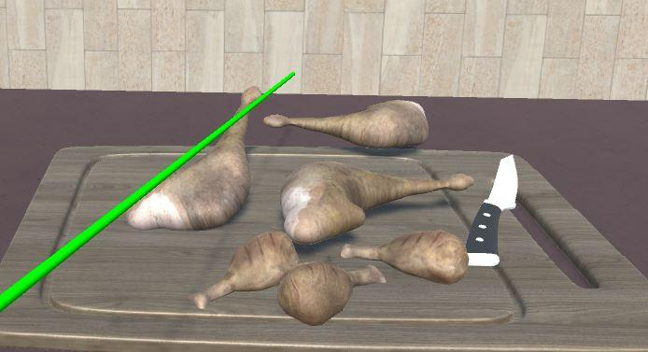

##### Fig B.8 - Chopping process is carried out and the unchopped FoodItem is replaced with the chopped FoodItem

1. You can continue to use the chopping board for other items as the display is updated with the chopped item removed

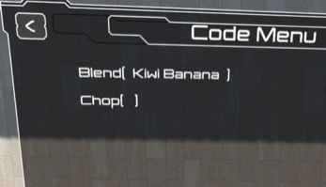

##### 

##### Fig B.9 - The Code Menu is updated with the FoodItem removed from *Chop()*

Note: You can place multiple items on the chopping board at once and chop them all together, or even do them individually

**Blending Food Items**

There are several food items that you can use for blending. Proceed as follows:

1. Use the Grabbing Wand to grab the blender from the shelf and place it anywhere on the platform
2. You will see the Code Menu update with the function *Blend()*
3. Go back to the shelf and grab the food items that can be blended (see Object Interactions for which items have the blending functionality)
4. Place the food item in the blender, one at a time
5. You will see the Code Menu update with the function *Blend(FoodItem)*
6. Again go back to the shelf and grab a certain number of glasses you want filled with the blended juice
7. Place these glasses on the platform next to the blender
8. Using the Pointing Wand, point at the food items or the blender, and then activate the wand

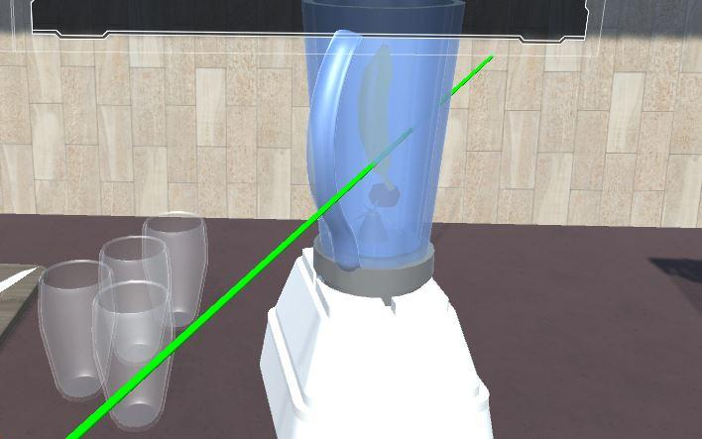

##### Fig B.10 - The glasses are placed on the platform, the pointing wand is pointed at the blender and the wand button is pressed

1. You will see the food items blended into juice
2. The Code Menu then displays a loop to fill out each glass with juice

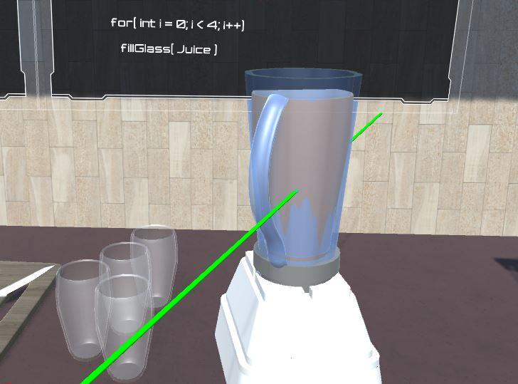

##### Fig B.11 - The display is updated with the loop and the blending process is carried out, replacing the fruits inside the blender with juice

1. The glasses are filled out one at a time, while an equivalent amount of juice is emptied from the blender

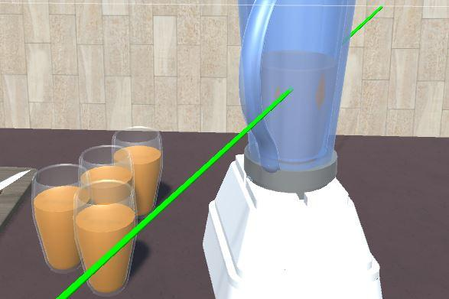

##### Fig B.12 - The juice in the blender is emptied and the glasses are filled out

Note: You can place multiple items in the blender at once and blend them all together, or even do them individually

**Object Interactions**

PlatformObjects

* Chopping Board
* Blender

FoodItems that can be chopped

* Chicken
* Potato
* Cheese

FoodItems that can be blended (any fruit)

* Banana
* Kiwi
* Watermelon
* Mango